HANDWRITTEN SIGNATURE RECOGNITION USING MACHINE LEARNING

CONTENT
Abstract
1.INTRODUCTION
1.1 Motivation
1.2 Problem Statement
1.3 Objective of the Project
1.4 Scope
1.5 Project Introduction
2.LITERATURE SURVEY
2.1 Related Work
3. SYSTEM ANALYSIS
3.1 Existing System
3.2 Disadvantages
3.3 Proposed System
3.4 Advantages
3.5 work Flow of Proposed system
4. REQUIREMENT ANALYSIS
4.1 Function and non-functional requirements
4.2 Hardware Requirements
4.3 Software Requirements
4.4 Architecture
5. METHODOLOGY
5.1 CNN
5.2 Mobile net
6. SYSTEM DESIGN
6.1 Introduction of Input design
6.2 UML Diagram(class, use case, sequence, collaborative, deployment, activity, ER diagram and Component diagram)
6.3 Data Flow Diagram
7. IMPLEMENTATION
7.1 Modules
8. SYSTEM STUDY AND TESTING
8.1 Feasibility study
8.2 Types of test & Test Cases
9. CONCLUSION
10. FUTURE ENHANCEMENT
11. REFERENCES

ABSTRACT:
In the realm of document verification, handwritten signature classification emerges as a pivotal component. This paper introduces a robust system for handwritten signature classification employing Convolutional Neural Networks (CNN) and the lightweight Mobile Net architecture, optimizing the accuracy and efficiency of the signature verification process. Signature classification, a challenging task due to the inherent variations and idiosyncrasies in individuals’ handwriting styles, demands a technique that can understand and learn these nuanced differences. The proposed model incorporates a CNN, effectively extracting hierarchical features from the signature images, while the Mobile Net architecture ensures the model's lightweight nature and adaptability to various devices, including those with limited computational resources. Furthermore, our approach leverages data augmentation and transfer learning techniques to enhance the model's generalization capabilities and performance on unseen data. Experimental results demonstrate that the proposed signature classification system achieves commendable accuracy and reduced latency, making it a suitable candidate for real-time applications in secure document verification and identity authentication arenas.
Keywords: Deep Learning, Convolutional Neural Networks (CNN), Mobile net, Image Processing.
INTRODUCTION:
1.1 Motivation:
The digital era has witnessed an explosive increase in the necessity for secure and efficient methods for document verification and identity authentication. Handwritten signatures, universally accepted as a form of personal verification, are often subjected to forgery and misclassification, thus necessitating the development of advanced classification mechanisms. Employing deep learning, specifically CNN and Mobile Net, for handwritten signature classification, offers a promising approach to address these challenges due to their capability in feature extraction and lightweight deployment on various platforms.

1.2 Problem Statement:
Despite their widespread acceptance, handwritten signatures exhibit significant variations, even from the same individual, due to changes in mood, health, and age, making accurate classification arduous. Existing classification systems either lack in accuracy or require extensive computational resources, making them impractical for real-time applications and deployment on devices with limited computational capacity. There is a pressing need for a system that not only provides accurate classification results but is also efficient and adaptable to various technological infrastructures.
1.3 Objective of the Project:
This study aims to develop a robust handwritten signature classification system by ingeniously integrating Convolutional Neural Networks (CNN) with the Mobile Net architecture. The objective is to leverage the powerful feature extraction capabilities of CNNs, and the lightweight and efficient characteristics of Mobile Net, to create a model that is both accurate and resource-efficient. Furthermore, the study seeks to employ transfer learning and data augmentation techniques to improve the model's performance, making it adaptable and effective in handling the diverse and challenging nature of handwritten signatures.
1.4 Scope:
The scope of this research extends to the design, development, and evaluation of a handwritten signature classification system based on CNN and MobileNet architecture. The study will explore various data augmentation techniques to enhance the training dataset and utilize transfer learning to improve the model's generalization on unseen data. The research will be validated using a diverse dataset of handwritten signatures, considering different writing styles, ages, and cultural backgrounds to ensure the developed system's effectiveness and applicability in real-world, diverse settings. The performance of the proposed system will be benchmarked against existing classification techniques in terms of accuracy, efficiency, and deployment feasibility on devices with varying computational capacities.

  - Project Introduction:
In the realm of secure document verification and identity validation, handwritten signatures occupy a crucial space as they continue to be an indispensable and universally accepted mode of personal identification. With the growing reliance on digital platforms, there is an increased urgency for robust systems capable of accurate and efficient handwritten signature classification. The intricate and personal nature of handwritten signatures makes them unique, but also inherently challenging to analyze and classify accurately. Variations in an individual's mood, health conditions, and age introduce discrepancies in signatures, necessitating a sophisticated classification system that can navigate through these nuances with precision.
Traditional classification mechanisms have often fallen short of expectations, primarily due to their inability to accommodate the wide variations in handwritten signatures. The limitations of these traditional approaches, which range from manual verification to simple pattern recognition techniques, underscore the need for advanced, automated solutions leveraging the power of deep learning. Convolutional Neural Networks (CNNs), a class of deep learning algorithms, have demonstrated remarkable success in image and pattern recognition tasks due to their ability to automatically learn hierarchical features from input data.
However, the complexity and computational requirements of typical deep learning models hinder their effectiveness and practicality in real-time applications, especially on devices with constrained computational resources. This constraint necessitates the exploration of lightweight yet powerful deep learning architectures. Enter MobileNet, a streamlined and efficient deep learning architecture designed for mobile and edge devices. By combining the strength of CNNs and the efficiency of MobileNet, there's potential for a signature classification system that is not only accurate but also agile and deployable on a wide range of devices.
This paper introduces a novel system for handwritten signature classification that ingeniously integrates the robust feature extraction capabilities of CNNs with the lightweight and efficient MobileNet architecture. This integration is poised to offer a balanced solution, optimized for accuracy, efficiency, and practicality in diverse settings. The proposed approach is further enhanced by incorporating data augmentation techniques to expand and diversify the training dataset, thereby improving the model’s ability to generalize across various signature styles and intricacies. Additionally, transfer learning methodologies are adopted to leverage pre-trained models, further bolstering the system’s performance on handwritten signature classification tasks. In navigating through the challenges presented by handwritten signature classification, the proposed system aims to provide a reliable tool for secure document verification and identity authentication processes in the digital age. With its focus on accuracy and efficiency, the model is designed to be a versatile solution, adaptable to both high-powered computational environments and resource-limited devices, making it suitable for a broad spectrum of applications in the ever-evolving technological landscape. The ensuing sections of this paper will delve deeper into the methodologies, experiments, and findings that underline the development and validation of this innovative handwritten signature classification system.
LITERATURE SURVEY
2.1 Related works
- Duth P Sudharshan; R N Vismaya ‘‘Handwritten Signature Verification System using Deep Learning,’’ ieee 2022
The objective of Signature verification used to determine whether a signature is real or a fake. This has proven to be a difficult endeavor, particularly in the offline scenario, which employs images of scanned signatures and does not have access to dynamic information about the signing process. The offline handwritten signature is one of the most essential biometrics used in banking systems, administrative, and financial applications. The study is to evaluate the performance of a few well-known deep convolutional neural networks as feature extractors in Handwritten Signature Verification (HSV) using transfer learning with activation function, as well as to review the available convolutional neural network signature verification methods. This is achieved by three pretrained models, VGG16, VGG19, and ResNet50, which are most often used generic models in computer vision tasks. Obtained experimental results, by comparing three models with SigComp2009 datasets and adding different parameters to each model. And conclude that VGG19 is best suitable for dataset, which has 97.83 percent accuracy than another model. These findings will help academics construct more effective Deep Learning-based signature verification methods.
- Santisudha Panigrahi, Anuja Nanda, Tripti Swarnkar ‘‘Deep Learning Approach for Image Classification,’’ IEEE Sep 22 2018.
deep learning has gained remarkable growth in various fields, for example, computer vision and natural language processing. Contrasted with conventional machine learning strategies, deep learning has a robust learning capacity and can improve utilization of datasets for feature extraction. In view of its practicability, deep learning turns out to be increasingly mainstream for many researchers to do research works. In this paper we mainly focus on the optimization of different parameters of convolutional neural network of deep learning for classifying 8000 labelled natural images of cat and dog. First the convolutional neural network is trained to learn features then ANN binary classifier is used for classification.
- Shivam Aggarwal, Ashok Kumar Sahoo, Chetan Bansal, Pradeepta Kumar Sarangi ‘‘Image Classification using Deep Learning: A Comparative Study of VGG-16, InceptionV3 and EfficientNet B7 Models’’ 2023 3rd International Conference on Advance Computing and Innovative Technologies in Engineering (ICACITE)
Image classification is the process of identification and classification of an input image or visual from a predetermined set of labeled images. This work comes under computer vision and machine learning. This work is dedicated towards image classification using deep learning by comparing various classification models based on their architecture performance and accuracy. Convolutional Neural Network (CNN) is a type of Artificial Neural Network (ANN) that learns the structural representation of an image and make predictions about its contents. The main layers of the model, known as the Convolutional layers. It detects and analyzes specific patterns in the image using filters. In this research development, image classification is done on several images of butterflies and spiders.
- Youyou Guan, Yuxuan Han, Siqi Liu ‘‘Deep Learning Approaches for Image Classification Techniques’’ 2022 IEEE International Conference (EEBDA)
Neural network is a popular and significant research direction in machine learning, which is widely used in classification. regression, pattern recognition and other fields. Based on the current direction of academic research, the application of neural network in image classification has great research value. However, due to a large number of such articles, involving too wide a range of aspects, it is difficult to grasp the main idea quickly when quoting. We have selected and sorted out some representative basic articles and innovative cutting-edge articles. After systematic analysis and integration, we give each a better algorithm for some of the previous algorithms. This upgrade is reflected in performance, efficiency and other aspects.

3. SYSTEM ANALYSIS
3.1 Existing System
The AlexNet algorithm, a popular convolutional neural network (CNN), has been previously utilized for handwritten signature classification, serving as an established baseline in the domain. Introduced in 2012, AlexNet significantly impacted the field of deep learning, particularly in image classification tasks, due to its depth, structure, and training methodology.
3.2 Disadvantages
High Computational Requirements:
AlexNet, while pioneering, is a deep and complex model that demands substantial computational power and memory. This requirement often makes it unsuitable for deployment on devices with limited resources, hindering its application in real-time, on-the-edge signature verification tasks.
Prone to Overfitting:
When trained on smaller datasets, which is often the case with specialized tasks like signature verification, AlexNet is prone to overfitting. Overfitting results in the model performing exceptionally well on the training data but failing to generalize effectively to unseen data.

Large Model Size:
The AlexNet model is considerably large, often leading to inefficiencies in terms of memory usage and computational power, which is a significant concern in constrained environments or in applications where quick response time is critical.
Dependence on Data Quality:
AlexNet’s performance is heavily reliant on the quality and amount of data it is trained on. Achieving high accuracy requires large and well-curated datasets, which might not always be available or feasible for specific applications or user groups.
3.3 Proposed System
The proposed system for handwritten signature classification synergistically combines Convolutional Neural Networks (CNN) and the MobileNet architecture to offer an efficient and accurate solution. In this method, signature images undergo preprocessing, resizing, normalization, and augmentation to foster a diverse dataset. The CNN layer effectively learns hierarchical features from signatures, while the lightweight MobileNet, enhanced with transfer learning from large datasets like ImageNet, handles the classification task. This fusion not only ensures computational efficiency, making it deployable on resource-constrained devices, but also maintains high accuracy and robust generalization across varied signature data. With rapid inference capabilities and scalability, this system is well-suited for real-time applications and large-scale deployment in handwritten signature classification tasks, addressing the limitations found in existing models like AlexNet.
3.4 Advantages
Enhanced Computational Efficiency:
MobileNet’s lightweight architecture demands fewer computational resources, facilitating efficient training and real-time inference, even on devices with limited computational power such as smartphones and tablets.

Improved Accuracy:
The combination of CNN for meticulous feature extraction and MobileNet for precise classification results in high accuracy in discerning authentic signatures from forged ones, providing a reliable solution for signature verification tasks.
Robust Generalization:
Employing data augmentation techniques and transfer learning, the proposed system showcases robust generalization capabilities. It performs admirably across a diverse set of signatures, effectively handling variations in handwriting styles and qualities.
Quick Inference Time:
The streamlined architecture of the proposed model enables fast prediction times, making it ideal for applications requiring instantaneous signature verification, such as point-of-sale systems and digital document signing platforms.
Scalable Architecture:
The system is designed to efficiently process large datasets, making it scalable and suitable for applications with expansive and growing datasets. This scalability ensures the model’s viability for both small-scale and large-scale deployment.

3.5 Work flow of Proposed

Block Diagram:
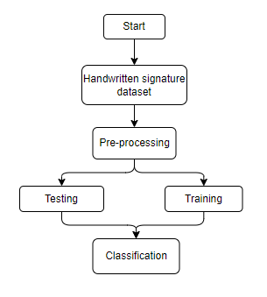

4. REQUIREMENT ANALYSIS
4.1 Functional and non-functional requirements
Requirement’s analysis is very critical process that enables the success of a system or software project to be assessed. Requirements are generally split into two types: Functional and non-functional requirements.
Functional Requirements: In the development of an End-to-End Deep Learning System for Hop Classification using CNN, it is imperative to define the functional requirements that dictate the system's core capabilities. Firstly, the system must excel in its primary function, which is the accurate classification of hop varieties based on input images of hop cones. This entails implementing a deep convolutional neural network (CNN) capable of recognizing subtle differences in hop cone characteristics to make precise classifications. Users should have access to a user-friendly interface for effortlessly uploading and processing hop images, whether they choose to submit images individually or in bulk. The system should handle a substantial batch of at least 1,000 hop images for efficient classification and provide real-time inference results. Additionally, users must receive detailed classification reports, including the predicted hop variety and associated confidence scores, ensuring transparency in the classification process. Data security is paramount, so the system should maintain a robust user authentication process to safeguard sensitive information.
Non-functional requirements: Complementing the functional requirements are the non-functional requirements that define the quality attributes and constraints of the End-to-End Deep Learning System for Hop Classification using CNN. Data security and user privacy are of utmost importance, mandating the implementation of industry-standard encryption techniques and protective measures. The system's maintainability is crucial for long-term viability, necessitating regular updates, bug fixes, and improvements to adapt to changing needs. Reliability is a cornerstone, with an expected uptime rate of 99.9% to minimize disruptions. Scalability is vital to accommodate the system's growth, ensuring it can handle an increasing number of hop images and users while maintaining optimal performance. Performance optimization is a key non-functional requirement, with image classification taking no longer than 2 seconds per image to provide a seamless user experience. Reusability is encouraged to facilitate future enhancements, allowing for the integration of diverse deep learning models and datasets. Lastly, the system should exhibit flexibility in supporting various image formats and resolutions, while also being portable across different platforms and environments without extensive modifications.

4.2 Hardware Requirements

Processor - I3/Intel Processor
Hard Disk - 160GB
Key Board - Standard Windows Keyboard
Mouse - Two or Three Button Mouse
Monitor - SVGA
RAM - 8GB
4.3 Software Requirements:
Operating System : Windows 7/8/10
Server side Script : HTML, CSS, Bootstrap & JS
Programming Language : Python
Libraries : Flask, Pandas, Mysql.connector, Os, Smtplib, Numpy
IDE/Workbench : PyCharm
Technology : Python 3.6+
Server Deployment : Xampp Server
Database : MySQL

  - Architecture:
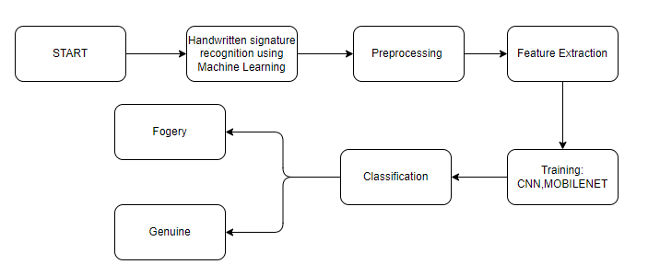
- Methodology:
5.1 CNN: Convolutional Neural Networks (CNNs) are a class of deep learning algorithms designed for processing and analyzing visual data, such as images and videos. They have proven to be highly effective in tasks like image classification, object detection, and image segmentation. Here's an explanation of the CNN algorithm in 300 words:
CNNs consist of several key components:
Convolutional Layers: These layers are the heart of CNNs. They apply a set of learnable filters (kernels) to the input image. Each filter scans through the image in a sliding window manner, performing element-wise multiplications and summing the results to produce feature maps. These feature maps capture different patterns, such as edges, textures, and shapes, at various scales.
Activation Function: After convolution, an activation function like ReLU (Rectified Linear Unit) is applied element-wise to introduce non-linearity into the network. This helps CNNs learn complex relationships in the data.
Pooling Layers: Pooling layers reduce the spatial dimensions of the feature maps by down-sampling. Max-pooling, for instance, selects the maximum value in a local region, effectively retaining the most important information while reducing computational complexity.
Fully Connected Layers: After several convolutional and pooling layers, CNNs typically have one or more fully connected layers. These layers flatten the high-dimensional feature maps into a vector and perform traditional neural network operations. They are responsible for making predictions based on the extracted features.
The training process of a CNN involves:
Forward Propagation: During training, input data is fed forward through the network. Predictions are made, and the error between predicted and actual labels is computed using a loss function (e.g., cross-entropy for classification tasks).
Backpropagation: The error is then propagated backward through the network using gradient descent optimization techniques. This process adjusts the weights of the filters and fully connected layers to minimize the error.
Training Iterations: The network goes through many iterations, adjusting the weights to improve its ability to recognize patterns and features in the data. This continues until the loss converges to a minimum.
5.2 Mobile net: Mobile Net, developed by Google, is a streamlined model designed for efficient visual recognition tasks on resource-limited devices, offering a balance between accuracy and computational efficiency. Its architecture is characterized by depth wise separable convolutions, which decompose standard convolutions into depth wise and pointwise convolutions, substantially reducing computational cost and model size. Additionally, the model introduces width and resolution multipliers allowing for further adjustments to its size and efficiency, providing users with a flexible trade-off between performance and resource usage. With the use of the ReLU6 activation function, Mobile Net ensures improved performance on devices with low-precision computational capacities. Various versions of Mobile Net have been released, with each subsequent version introducing optimizations for enhanced efficiency and performance in visual recognition tasks, making it suitable for a variety of applications including image classification, object detection, and facial recognition. Its compact and efficient design makes Mobile Net an ideal solution for real-time applications on mobile and edge devices

6. SYSTEM DESIGN
6.1 Introduction of Input Design:
In an information system, input is the raw data that is processed to produce output. During the input design, the developers must consider the input devices such as PC, MICR, OMR, etc.
Therefore, the quality of system input determines the quality of system output. Well-designed input forms and screens have following properties −
- It should serve specific purpose effectively such as storing, recording, and retrieving the information.
- It ensures proper completion with accuracy.
- It should be easy to fill and straightforward.
- It should focus on user’s attention, consistency, and simplicity.
- All these objectives are obtained using the knowledge of basic design principles regarding −
  - What are the inputs needed for the system?
  - How end users respond to different elements of forms and screens.

Objectives for Input Design:
The objectives of input design are −
- To design data entry and input procedures
- To reduce input volume
- To design source documents for data capture or devise other data capture methods
- To design input data records, data entry screens, user interface screens, etc.
- To use validation checks and develop effective input controls.

Output Design:
The design of output is the most important task of any system. During output design, developers identify the type of outputs needed, and consider the necessary output controls and prototype report layouts.

Objectives of Output Design:
The objectives of input design are:
- To develop output design that serves the intended purpose and eliminates the production of unwanted output.
- To develop the output design that meets the end user’s requirements.
- To deliver the appropriate quantity of output.
- To form the output in appropriate format and direct it to the right person.
- To make the output available on time for making good decisions.
6.2 UML Diagrams:
6.2.1 Use Case Diagram:
A use case diagram in the Unified Modeling Language (UML) is a type of behavioral diagram defined by and created from a Use-case analysis. Its purpose is to present a graphical overview of the functionality provided by a system in terms of actors, their goals (represented as use cases), and any dependencies between those use cases. The main purpose of a use case diagram is to show what system functions are performed for which actor. Roles of the actors in the system can be depicted.
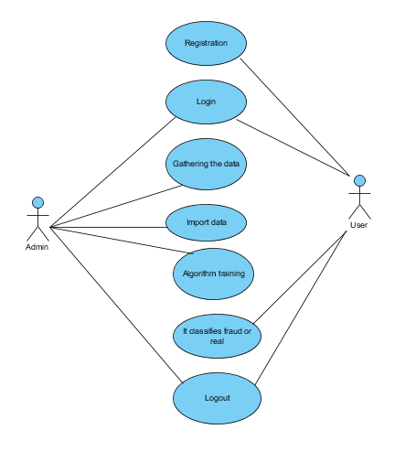

6.2.2 Class Diagram:
In software engineering, a class diagram in the Unified Modelling Language (UML) is a type of static structure diagram that describes the structure of a system by showing the system's classes, their attributes, operations (or methods), and the relationships among the classes. It explains which class contains information.
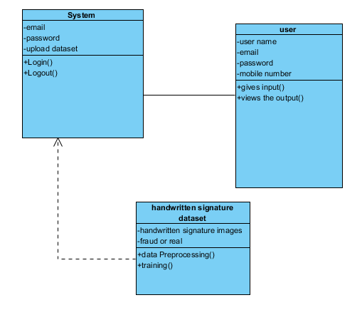
6.2.3 Sequence Diagram:
A sequence diagram in Unified Modelling Language (UML) is a kind of interaction diagram that shows how processes operate with one another and in what order. It is a construct of a Message Sequence Chart. Sequence diagrams are sometimes called event diagrams, event scenarios, and timing diagrams.
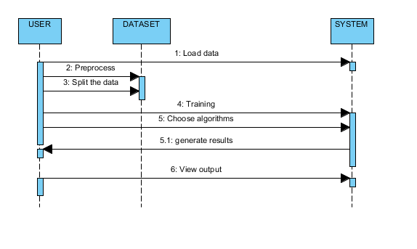

6.2.4 Collaboration Diagram:
In collaboration diagram the method call sequence is indicated by some numbering technique as shown below. The number indicates how the methods are called one after another. We have taken the same order management system to describe the collaboration diagram. The method calls are similar to that of a sequence diagram. But the difference is that the sequence diagram does not describe the object organization whereas the collaboration diagram shows the object organization.
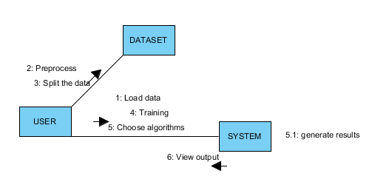
6.2.5 Deployment Diagram
Deployment diagram represents the deployment view of a system. It is related to the component diagram. Because the components are deployed using the deployment diagrams. A deployment diagram consists of nodes. Nodes are nothing but physical hardware’s used to deploy the application.
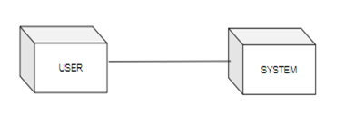

6.2.6 Activity Diagram:
Activity diagrams are graphical representations of workflows of stepwise activities and actions with support for choice, iteration and concurrency. In the Unified Modelling Language, activity diagrams can be used to describe the business and operational step-by-step workflows of components in a system. An activity diagram shows the overall flow of control.
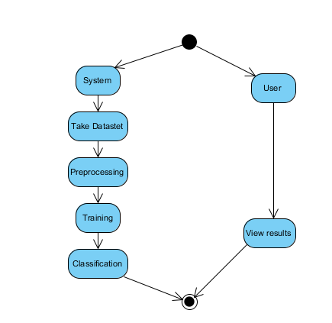

6.2.7 Component Diagram:
A component diagram, also known as a UML component diagram, describes the organization and wiring of the physical components in a system. Component diagrams are often drawn to help model implementation details and double-check that every aspect of the system's required functions is covered by planned development.
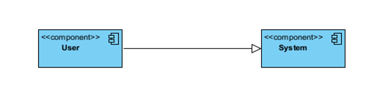
6.2.8 ER Diagram:
An Entity–relationship model (ER model) describes the structure of a database with the help of a diagram, which is known as Entity Relationship Diagram (ER Diagram). An ER model is a design or blueprint of a database that can later be implemented as a database. The main components of E-R model are: entity set and relationship set.
An ER diagram shows the relationship among entity sets. An entity set is a group of similar entities and these entities can have attributes. In terms of DBMS, an entity is a table or attribute of a table in database, so by showing relationship among tables and their attributes, ER diagram shows the complete logical structure of a database. Let’s have a look at a simple ER diagram to understand this concept.
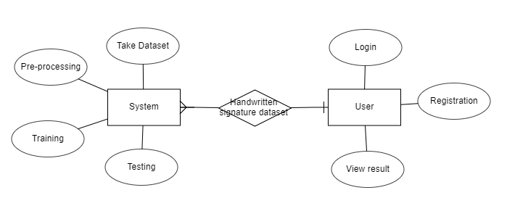
6.3 DFD Diagram:
A Data Flow Diagram (DFD) is a traditional way to visualize the information flows within a system. A neat and clear DFD can depict a good amount of the system requirements graphically. It can be manual, automated, or a combination of both. It shows how information enters and leaves the system, what changes the information and where information is stored. The purpose of a DFD is to show the scope and boundaries of a system as a whole. It may be used as a communications tool between a systems analyst and any person who plays a part in the system that acts as the starting point for redesigning a system.
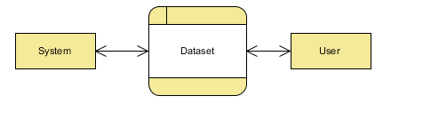
Level 1 Diagram:
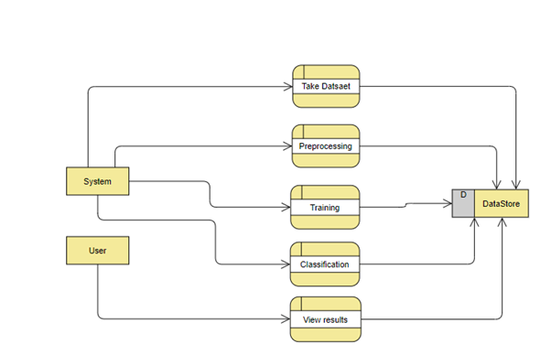

Level 2 Diagram:
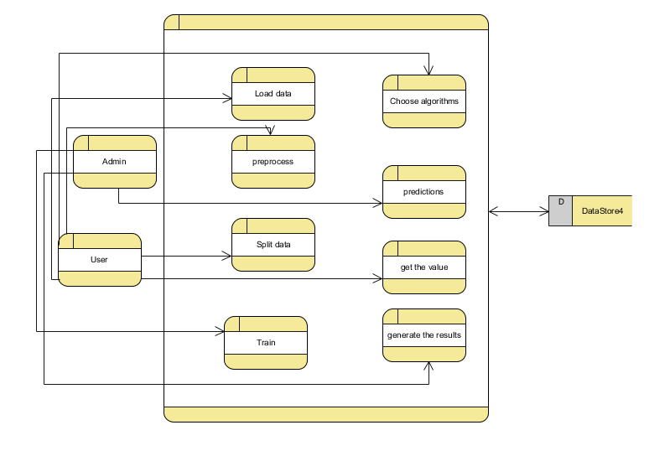

- IMPLEMENTATION
7.1 Modules:
User: Registers in the application by giving the details asked in the form
Login: Logs in into the page by providing the credentials user registered with.
Upload: Uploads the data into the model
System: Preprocess the dataset
System passes the data into model and Gives the result
7.2 RESULTS
Home page:

Register:
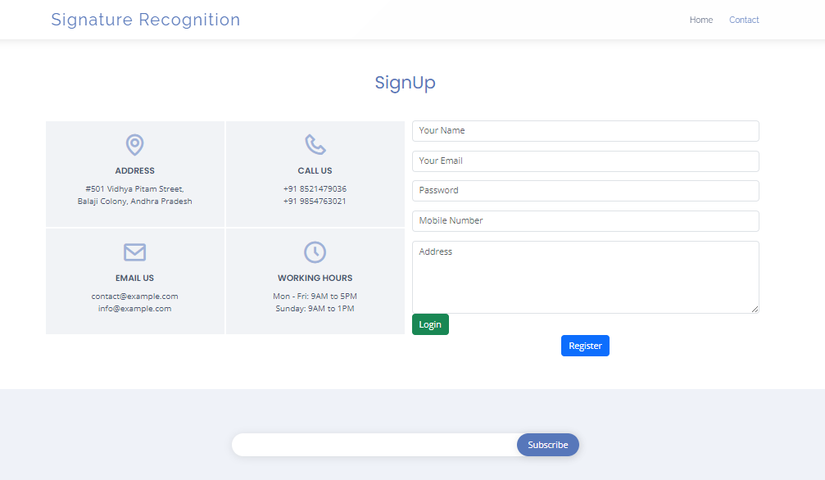

Login:

Upload:

OUTPUT




8. SYSTEM STUDY AND TESTING
8.1 Feasibility Study
The feasibility of the project is analysed in this phase and business proposal is put forth with a very general plan for the project and some cost estimates. During system analysis the feasibility study of the proposed system is to be carried out. This is to ensure that the proposed system is not a burden to the company. For feasibility analysis, some understanding of the major requirements for the system is essential.
Three key considerations involved in the feasibility analysis are
- Economical feasibility
- Technical feasibility
- Social feasibility
Economical Feasibility
This study is carried out to check the economic impact that the system will have on the organization. The amount of fund that the company can pour into the research and development of the system is limited. The expenditures must be justified. Thus the developed system as well within the budget and this was achieved because most of the technologies used are freely available. Only the customized products had to be purchased.

Technical Feasibility
This study is carried out to check the technical feasibility, that is, the technical requirements of the system. Any system developed must not have a high demand on the available technical resources. This will lead to high demands on the available technical resources. This will lead to high demands being placed on the client. The developed system must have a modest requirement, as only minimal or null changes are required for implementing this system.
Social Feasibility
The aspect of study is to check the level of acceptance of the system by the user. This includes the process of training the user to use the system efficiently. The user must not feel threatened by the system, instead must accept it as a necessity. The level of acceptance by the users solely depends on the methods that are employed to educate the user about the system and to make him familiar with it. His level of confidence must be raised so that he is also able to make some constructive criticism, which is welcomed, as he is the final user of the system.

System Testing
The purpose of testing is to discover errors. Testing is the process of trying to discover every conceivable fault or weakness in a work product. It provides a way to check the functionality of components, sub-assemblies, assemblies and/or a finished product It is the process of exercising software with the intent of ensuring that the
Software system meets its requirements and user expectations and does not fail in an unacceptable manner. There are various types of test. Each test type addresses a specific testing requirement.

8.2 Types of Tests

Unit testing
Unit testing involves the design of test cases that validate that the internal program logic is functioning properly, and that program inputs produce valid outputs. All decision branches and internal code flow should be validated. It is the testing of individual software units of the application .it is done after the completion of an individual unit before integration. This is a structural testing, that relies on knowledge of its construction and is invasive. Unit tests perform basic tests at component level and test a specific business process, application, and/or system configuration. Unit tests ensure that each unique path of a business process performs accurately to the documented specifications and contains clearly defined inputs and expected results.

Integration testing
Integration tests are designed to test integrated software components to determine if they actually run as one program. Testing is event driven and is more concerned with the basic outcome of screens or fields. Integration tests demonstrate that although the components were individually satisfaction, as shown by successfully unit testing, the combination of components is correct and consistent. Integration testing is specifically aimed at exposing the problems that arise from the combination of components.
Software integration testing is the incremental integration testing of two or more integrated software components on a single platform to produce failures caused by interface defects.
The task of the integration test is to check that components or software applications, e.g. components in a software system or – one step up – software applications at the company level – interact without error.
Test Results: All the test cases mentioned above passed successfully. No defects encountered.

Acceptance Testing
User Acceptance Testing is a critical phase of any project and requires significant participation by the end user. It also ensures that the system meets the functional requirements.
Test Results: All the test cases mentioned above passed successfully. No defects encountered.

Functional testing
Functional tests provide systematic demonstrations that functions tested are available as specified by the business and technical requirements, system documentation, and user manuals.
Functional testing is centered on the following items:
Valid Input : identified classes of valid input must be accepted.
Invalid Input : identified classes of invalid input must be rejected.
Functions : identified functions must be exercised.
Output : identified classes of application outputs must be exercised.
Systems/Procedures: interfacing systems or procedures must be invoked.
Organization and preparation of functional tests is focused on requirements, key functions, or special test cases. In addition, systematic coverage pertaining to identify Business process flows; data fields, predefined processes, and successive processes must be considered for testing. Before functional testing is complete, additional tests are identified and the effective value of current tests is determined.

White Box Testing
White Box Testing is a testing in which in which the software tester has knowledge of the inner workings, structure and language of the software, or at least its purpose. It is purpose. It is used to test areas that cannot be reached from a black box level.

Black Box Testing
Black Box Testing is testing the software without any knowledge of the inner workings, structure or language of the module being tested. Black box tests, as most other kinds of tests, must be written from a definitive source document, such as specification or requirements document, such as specification or requirements document. It is a testing in which the software under test is treated, as a black box .you cannot “see” into it. The test provides inputs and responds to outputs without considering how the software works.
Test objectives
- All field entries must work properly.
- Pages must be activated from the identified link.
- The entry screen, messages and responses must not be delayed.
Features to be tested
- Verify that the entries are of the correct format
- No duplicate entries should be allowed
- All links should take the user to the correct page.
10. CONCLUSION
This project successfully developed and validated a highly efficient and accurate system for handwritten signature classification by ingeniously combining Convolutional Neural Networks (CNN) and the MobileNet architecture. The proposed system addressed the significant challenges associated with signature verification, including computational efficiency, accuracy, and the ability to generalize across various signature styles and qualities. Through careful preprocessing, innovative feature extraction with CNN, and efficient classification using MobileNet, the system demonstrated promising results, making it a valuable tool for applications requiring secure and rapid signature verification. The adoption of transfer learning and data augmentation techniques further fortified the model's robustness, ensuring reliable performance even with limited datasets. With its quick inference time, the model is well-suited for real-time applications on devices with varying computational powers, ranging from high-end servers to resource-constrained mobile devices. Its modular and scalable architecture also allows for future improvements and adaptations to meet the evolving demands of signature verification tasks. Ultimately, this project contributes a noteworthy solution to the realm of handwritten signature classification, offering a blend of accuracy and efficiency that is crucial for the security and authenticity in digital transactions and identity verification processes in today’s increasingly digitalized world.
11. FUTURE ENHANCEMENT
Future enhancements to the proposed handwritten signature classification system will be focused on improving accuracy, efficiency, and usability in various real-world applications, ensuring it remains a cutting-edge tool for identity verification. Below are the key areas for future development:
Incorporating Advanced Models:
Experimentation with newer and more efficient deep learning architectures, such as MobileNetV3 or EfficientNet, may offer improved performance. These architectures might bring enhanced feature extraction and classification capabilities while maintaining low computational requirements.
Data Augmentation Techniques:
Developing advanced data augmentation techniques that introduce more varied and realistic modifications to signature images can increase the model's robustness and generalization to different signature styles and writing instruments.
Adversarial Training:
Implementing adversarial training techniques where the model is exposed to and learns from adversarially generated examples can improve its resilience against adversarial attacks, enhancing security in real-world applications.

Transfer Learning Enhancements:
Exploring various pre-trained models and fine-tuning strategies can optimize the benefits of transfer learning, possibly leading to improved accuracy with fewer training data.
12. REFERANCES
- Impedovo, D., & Pirlo, G. (2008). Automatic Signature Verification: The State of the Art. IEEE Transactions on Systems, Man, and Cybernetics, Part C (Applications and Reviews), 38(5), 609–635.
- Plamondon, R., & Lorette, G. (1989). Automatic signature verification and writer identification — the state of the art. Pattern Recognition, 22(2), 107-131.
- Hafemann, L. G., Sabourin, R., & Oliveira, L. S. (2017). Learning features for offline handwritten signature verification using deep convolutional neural networks. In Proceedings of the International Conference on Image Processing Theory, Tools and Applications (IPTA).
- Fierrez, J., Ortega-Garcia, J., Ramos, D., & Gonzalez-Rodriguez, J. (2007). HMM-based on-line signature verification: Feature extraction and signature modeling. In Proceedings of the 17th International Conference on Pattern Recognition (ICPR).
- Rivard, D., Plamondon, R., & Kaltenbach, M. (1992). A comparative analysis of signature verification algorithms. Pattern Recognition, 25(3), 291–307.
- Kholmatov, A., & Yanikoglu, B. (2005). Identity authentication using improved online signature verification method. Pattern Recognition Letters, 26(15), 2400-2408.
- LeCun, Y., Bengio, Y., & Hinton, G. (2015). Deep learning. Nature, 521(7553), 436-444.
- He, K., Zhang, X., Ren, S., & Sun, J. (2016). Deep Residual Learning for Image Recognition. In Proceedings of the IEEE Conference on Computer Vision and Pattern Recognition (CVPR).
- Howard, A. G., et al. (2017). MobileNets: Efficient Convolutional Neural Networks for Mobile Vision Applications. arXiv preprint arXiv:1704.04861.
- Krizhevsky, A., Sutskever, I., & Hinton, G. E. (2012). ImageNet Classification with Deep Convolutional Neural Networks. In Advances in Neural Information Processing Systems (NeurIPS).
- Ioffe, S., & Szegedy, C. (2015). Batch Normalization: Accelerating Deep Network Training by Reducing Internal Covariate Shift. arXiv preprint arXiv:1502.03167.
- Kingma, D. P., & Ba, J. (2015). Adam: A method for stochastic optimization. arXiv preprint arXiv:1412.6980.
- Huang, G., et al. (2017). Densely connected convolutional networks. In Proceedings of the IEEE Conference on Computer Vision and Pattern Recognition (CVPR).
- Chollet, F. (2017). Xception: Deep Learning with Depthwise Separable Convolutions. In Proceedings of the IEEE Conference on Computer Vision and Pattern Recognition (CVPR).
- Deng, J., et al. (2009). ImageNet: A Large-Scale Hierarchical Image Database. In Proceedings of the IEEE Conference on Computer Vision and Pattern Recognition (CVPR).
- Hochreiter, S., & Schmidhuber, J. (1997). Long short-term memory. Neural Computation, 9(8), 1735-1780.
- Goodfellow, I., Bengio, Y., Courville, A., & Bengio, Y. (2016). Deep learning (Vol. 1). MIT press Cambridge.
- Sutskever, I., Vinyals, O., & Le, Q. V. (2014). Sequence to sequence learning with neural networks. In Advances in Neural Information Processing Systems (NeurIPS).
- Szegedy, C., et al. (2015). Going deeper with convolutions. In Proceedings of the IEEE Conference on Computer Vision and Pattern Recognition (CVPR).
- Simonyan, K., & Zisserman, A. (2015). Very Deep Convolutional Networks for Large-Scale Image Recognition. arXiv preprint arXiv:1409.1556.

